***PRACTICAL No. 06***

***Assignment Tasks***

***Task 1: Prompt Categorization***

***Here’s how I’d categorize them, with quick reasoning:***

1. “Generate a logo for a tech startup using neon colors.”

* **Type:** Visual — Image/Design Generation
* **Why:** It requests a created visual asset (a logo) with a stylistic constraint (neon colors). Output is an image, not text.



1. “Explain blockchain to a 5-year-old.”

* **Type:** Instructional — Educational Explanation (Simplified)
* **Why:** It asks for a plain-language explanation tailored to a very young audience, emphasizing clarity, analogy, and simplicity.

1. “You are a UX designer. Suggest improvements to this app layout.”

* **Type:** Analytical/Consultative — Design Critique with Role Prompt
* **Why:** It frames the assistant as an expert (“You are a UX designer”) and seeks actionable recommendations on a (likely visual) artifact. Output is a critique/checklist, not an image.

***Task 2: Refinement Practice***

***Here’s the refinement for each vague prompt:***

1. **Original:** “Draw a house.”  
   **Refined:** “Create a detailed illustration of a two-story modern house with large glass windows, a red front door, and a garden filled with sunflowers, set during sunset.”
2. **Original:** “Write a story.”  
   **Refined:** “Write a 500-word short story set in a futuristic city where robots and humans live together, focusing on a young inventor who discovers a hidden AI with feelings.”
3. **Original:** “Make a video.”  
   **Refined:** “Produce a 1-minute promotional video for a coffee shop, featuring slow-motion shots of coffee being poured, close-ups of latte art, and upbeat background music.”

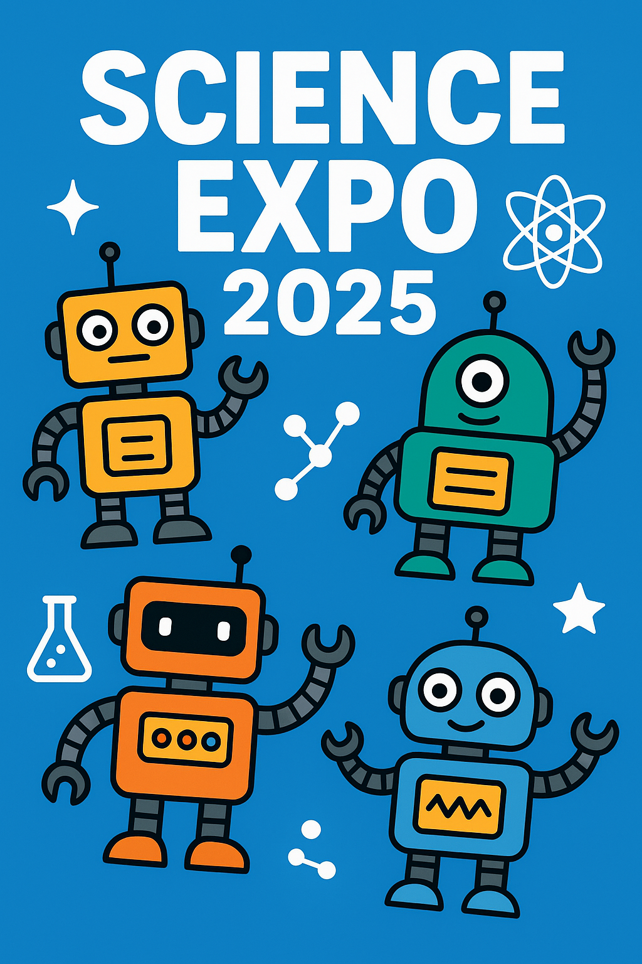

***Task 3: Prompt Design Exercise***

###### Here’s a set of 5 original prompts across different domains:

1. **ChatGPT (text-based)**  
   *Prompt:* “Write a motivational letter from a time-traveling scientist in the year 3025 to today’s youth, inspiring them to protect the environment.”
2. **DALL·E (image-based)**  
   *Prompt:* “Create a hyper-realistic illustration of a futuristic floating city with solar sails, glowing gardens, and flying electric taxis at sunset.”
3. **SORA (video-based)**  
   *Prompt:* “Generate a 15-second cinematic video showing a dragon flying over a medieval castle, with fire illuminating the night sky and villagers watching in awe.”
4. **Coding or Logic**  
   *Prompt:* “Write a Python program that simulates an online voting system, allowing users to register, cast votes, and display live results in a bar chart.”
5. **Education or Training**  
   *Prompt:* “Design a 30-minute interactive training module for beginners to learn basic cybersecurity practices, including password security, phishing awareness, and safe browsing habits.”